BACS2073 Software Design and Architecture Tutorial 8
Tutorial 8 – Software Design Quality
1. Analyse the requirements given below and provide relevant non-functional requirement. Explain your answer.
(a) System Y shall process a minimum of 8 transactions per second
(b) The system shall be developed for PC and Macintosh platforms
(c) The system must encrypt all external communications using the RSA algorithm
2. Given the four ‘ilities’ reliability, usability, maintainability, reusability, explain how you would rank them in order of importance for each of the following systems:
(a) A process control system for a chemical plant that produces toxic insecticides (b) A bank auto teller network used to issue cash and short statements describing accounts (c) An interactive database used for stock control at each branch of a chain of stores that sells electrical goods.
(d) A system for a network of self-service kiosks that can be used to top-up the credit amount in Touch-n-Go cards;
3. “Every system has real-time performance constraints.” Discuss. Or provide a counterexample.
4. Security and usability are often seen to be at odds with each other. Security often imposes procedures and processes that seem like needless overhead to the casual user. But some say that security and usability go (or should go) hand in hand and argue that making the system easy to use securely is the best way to promote security to the user. Discuss.
5. Explain why design conflicts might arise when designing an architecture for which both availability and security requirements are the most important non-functional requirements.
6. Many of design decisions for testability are also useful for achieving modifiability. Why do you think that is? Discuss your point of view.
Page 1 of 2
BACS2073 Software Design and Architecture Tutorial 8
7. Past Year
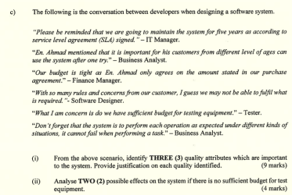Additional Question
a) The following is the conversation between users and developers while in the process of requirement gathering.
“ I need to check for the market price of items days and nights. It should show me the latest prices” – Melvin.
“ I prefer all the message I sent is the secret between me and my clients. Of course, it can be viewed by my boss.” – Arthur.
“Eh……I am not a good in using computer. Hope it will not disturb my daily work.” – Susan.
“I am the IT support for the company. I guess I may need to learn the system and prepare my self to provide necessary support to the users, there are huge chances that I may need to add in special functionality. My boss says that the source code will be provided, right?”- James.
“Ok, thanks for your opinions. We hope we won’t disappointed you.” – Evan.
From the above scenario, identify FOUR (4) quality attribute should be considered when designing the system. Provide justification on each quality identified. (12 marks)
Page 2 of 2

